The Glen

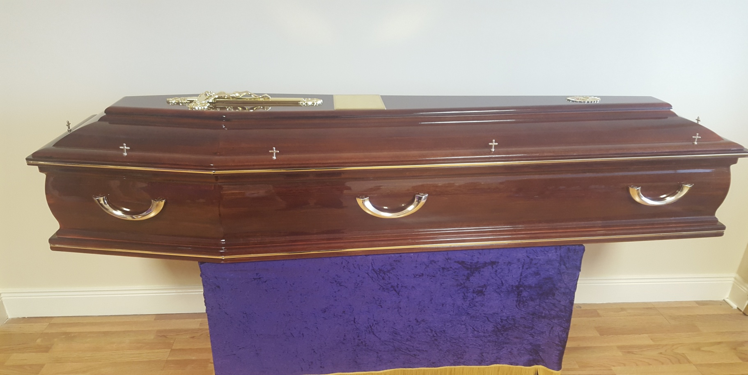

Solid mahogany shade Italian coffin with solid half moon handles and high gloss finish.